**SMART PUBLIC RESTROOM**

**Project objectives:**

**1. Enhanced User Experience**

Improve the overall user experience by providing real-time information on restroom availability and cleanliness. Facilitate touchless and convenient access through a mobile app.

2. **Optimized Resource Management:**

Monitor and manage restroom supplies (toilet paper, soap, etc.) efficiently using IoT sensors, reducing wastage and ensuring availability.

Automate maintenance alerts and cleaning schedules to maximize operational efficiency.

3. **Improved Hygiene and Safety:**

Ensure a cleaner and safer restroom environment by monitoring and maintaining hygiene levels with IoT sensors that monitors air.

Implement security measures for secure and authorized access to restrooms.

4. **Sustainability and Eco-Friendliness**

Promote sustainability by implementing energy-efficient lighting and water-

saving features based on occupancy.

Encourage eco-friendly practices within the restroom.

5. **Accessibility and Inclusivity**

Enhance accessibility by providing features like voice commands and braille instructions for people with disabilities.

Create an inclusive restroom experience for all users.

6. **Data-Driven Decision-Making:**

Collect and analyze restroom usage data to optimize resource allocation and

maintenance efforts.

Generate reports for facility managers to make informed decisions.

7. **User Feedback and Continuous Improvement:**

Enable users to provide feedback and ratings through the mobile app.Use feedback data to continuously improve restroom conditions and

services.

8 **Integration with IoT Ecosystem**

Seamlessly integrate the restroom system with other IoT devices and systems within the facility for cohesive operation.

9. **Cost-Efficiency and Resource Optimization**

Reduce operational costs through efficient resource management and maintenance.

Enhance the overall cost-effectiveness of restroom facilities.

**SENSORS USED :**

**Turbidity Sensor:**

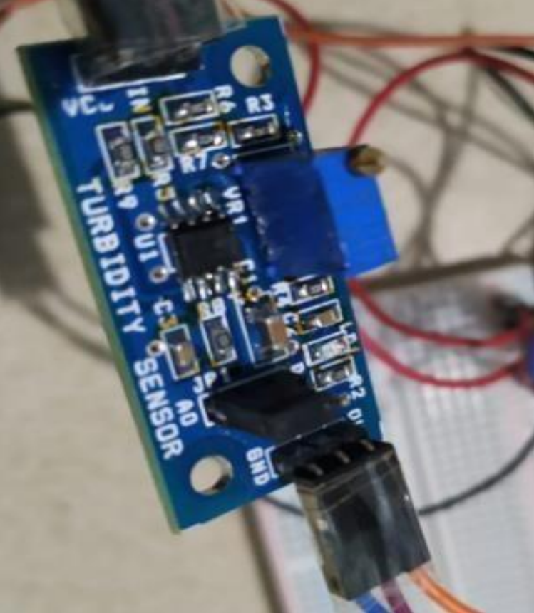

A turbidity sensor is a sensor which is mainly used to measure scattered light suspended by solids in water. As the number of total suspended solids in the water source is increased, the turbidity level of water is increased accordingly. Turbidity sensors can be used in the determination of water quality of small as well as large water bodies.

**MQ3 gas Sensor:**

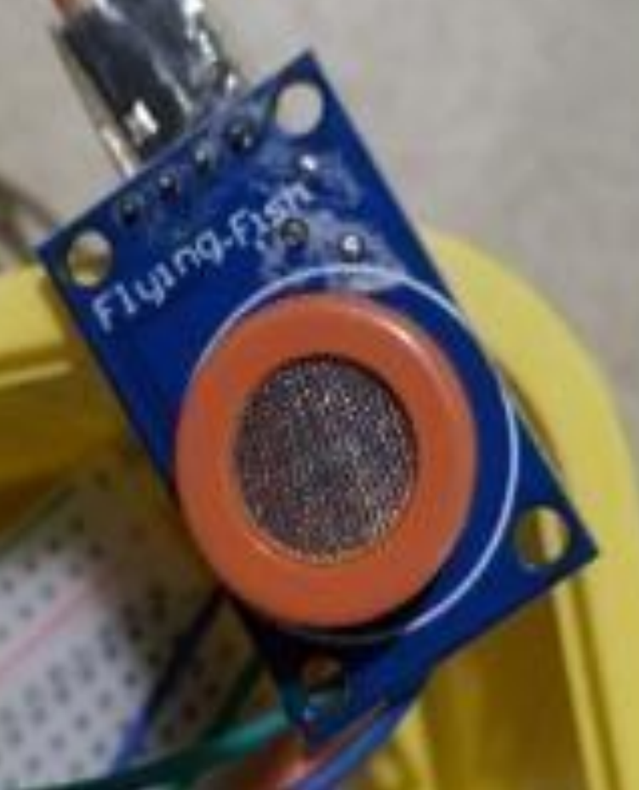

MQ3 gas sensor is an alcohol gas sensor which can detect the presence of gases which contain alcohol traces in them. It is made out of tin in the form of stannic oxide. It can detect alcohol, ethanol and smoke.

**Node MCU wifi module:**

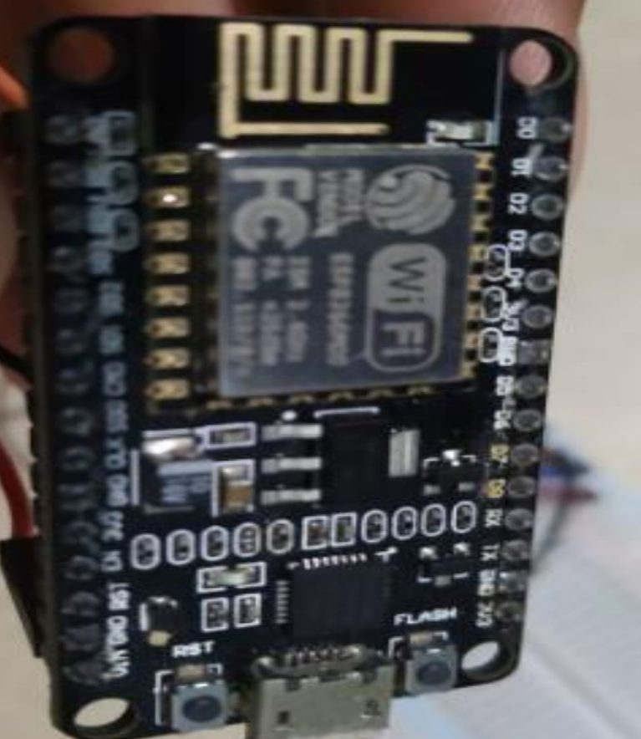

NodeMCU is a development kit that aids in making an IoT project. This module runs on ESP8266 Wi-Fi system on a chip. It is a microcontroller unit which includes a built in WiFi module.

**Passive Infrared (PIR) Sensors:**

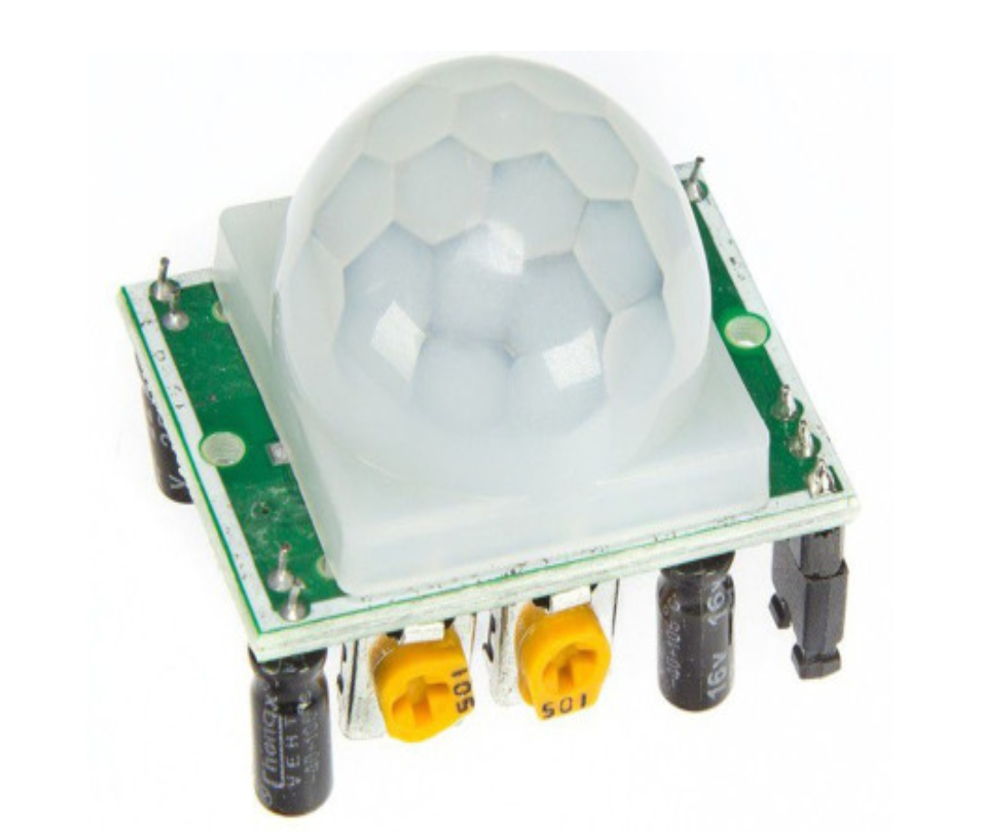

PIR sensors detect changes in heat signatures. When a person enters the restroom, their body heat triggers the sensor, signaling occupancy. PIR sensors are often used for controlling lighting and ventilation.

**IOT Hardware:**

Install IoT hardware like microcontrollers (e.g., Arduino or Raspberry Pi), Wi-Fi/Bluetooth modules, and power supplies. These will be the backbone of your sensor network.

**IOT Sensor Setup:**

The proposed system consists of two main portions: The first portion includes all the hardware components which pick up all of the data which is detected. The hardware includes the smell sensor, turbidity sensor,microcontroller, Wi-Fi module and the connecting wires. The second portion includes the details about how the data which is picked up is delivered to the organization. This portion includes the database software used to store the data of the foul smell

which is detected by the smell sensor and the data of the turbid water picked up by the turbidity sensor. Here, the microcontroller sends a signal to the organization through the Wi-Fi module. The user can access and get details about the notification through a mobile application which has been created for managing the toilet.

**Setting up an occupancy sensor in a Smart Public Restroom IoT system involves several steps:**

**1. Selecting the Right Sensor:** Choose an appropriate occupancy sensor for your restroom. Options include passive infrared (PIR) sensors, ultrasonic sensors, or newer technologies like AI-based cameras. Consider factors like accuracy, range, and power consumption.

**2. Power Supply**: Ensure a reliable power source, typically through wired or battery-powered options. Consider power efficiency and backup solutions to avoid sensor downtime.

**3. Sensor Placement:** Position the sensor in a strategic location within the restroom to cover the entire area. It's crucial to ensure that it can detect human presence accurately. Typically, you'd mount it on the ceiling or wall.

**4. Connectivity:** Connect the sensor to the IoT network. Common options include Wi-Fi, Bluetooth, or dedicated IoT protocols like LoRaWAN. Make sure it's securely connected to the central IoT platform.

**5. IoT Platform:** Set up an IoT platform to collect and process data from the sensor. Cloud-based solutions like AWS IoT, Azure IoT, or Google Cloud IoT are popular choices. Configure the platform to receive data from the sensor.

**6. Data Processing:** Define the logic for occupancy detection. Depending on the sensor type, you may need to filter out false positives (e.g., pets or moving objects). Use algorithms to determine occupancy status accurately.

**7. User Interface:** Create a user interface, which could be a mobile app or a web dashboard, to display real-time occupancy status. Users can check if the restroom is vacant or in use.

**8. Alerts and Notifications:** Implement notifications to alert users when the restroom becomes vacant. This can be done through SMS, mobile app notifications, or other communication channels.

**9. Privacy and Security:** Ensure data privacy and security. If using cameras, be mindful of privacy concerns and comply with relevant regulations. Encrypt data transmission and implement access control.

**10. Maintenance and Calibration**: Regularly maintain and calibrate the sensor to ensure it continues to function accurately.

**11. Scalability**: Plan for scalability if you intend to expand the system to multiple restrooms. Ensure the IoT platform can handle a growing number of sensors.

**12. Testing**: Thoroughly test the system to ensure accurate occupancy detection and a seamless user experience.

**13. Compliance**: Be aware of any local regulations and compliance requirements, especially if cameras are involved.

Remember that setting up an occupancy sensor in a public restroom requires careful planning, and addressing privacy and security concerns is crucial. Additionally, regular maintenance and updates are essential for a reliable and effective IoT system.

**Block diagram:**

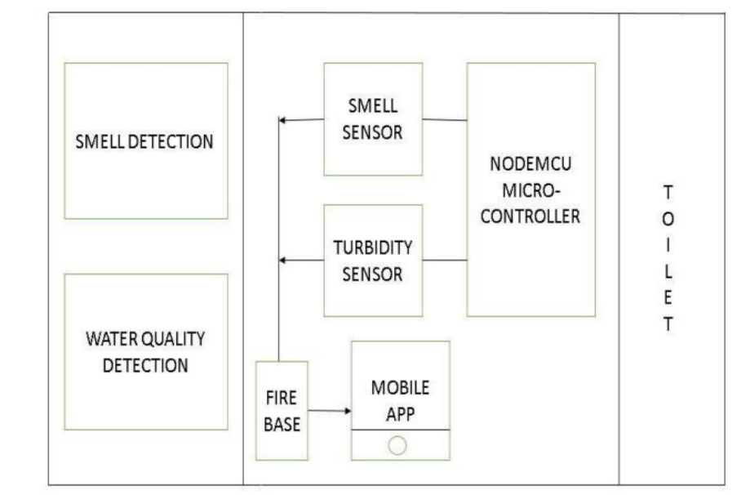

Block Diagram of Proposed System

**WORKING MODEL:**

The smell sensor is used to detect any unwanted gases present in the toilet. If any foul smell goes into the sensor, it creates a signal. The turbidity sensor tests the transparency of the water to measure its quality and check whether any

bacteria is present in the tank. If bacteria are detected, it creates a signal. All the signals are passed through the NodeMCU microcontroller where the constraints of foul smell and turbid water are checked. All of the data is stored

inside firebase, which stores all the information about the results. It is an application development software. The data is accessed through a mobile application where the management receives the output message which informs that the toilet must be cleaned. The organization must

install this application to access the alerts and view the data which has been received. Then a sweeper is sent to clean the toilet.

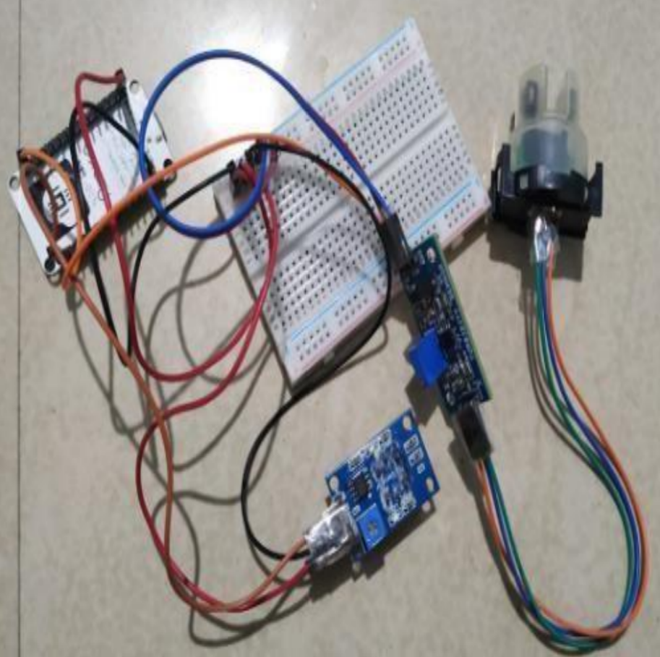

Working Model

**IMPLEMENTATION :**

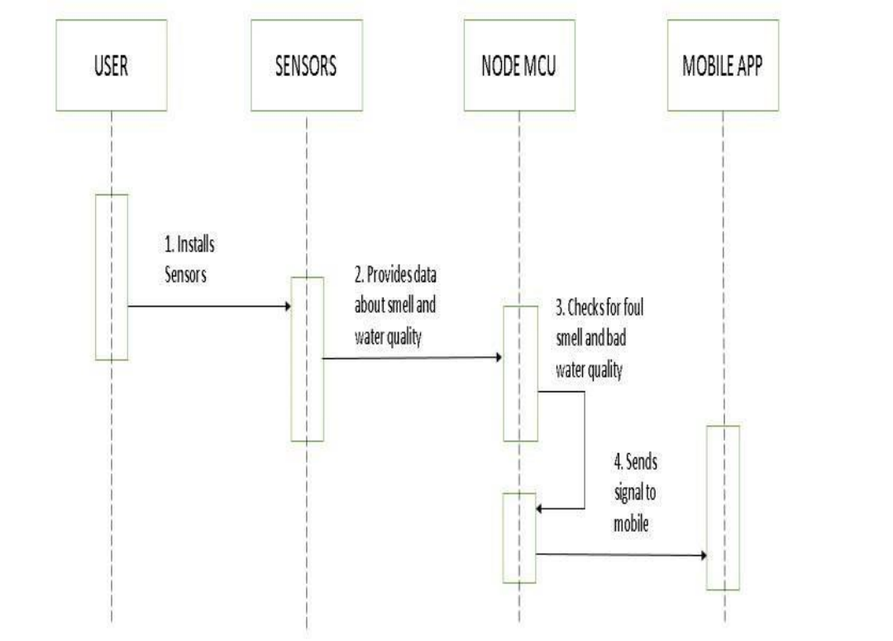

This section contains the implementation of the proposed model. Once the sensor is installed and a user has used the toilet, the gas sensor and turbidity check for the constraints. The turbidity sensor reads a lower current if the water is turbid. This sends a signal to NodeMCU which loads the values onto the database. Similarly, the gas sensor detects the foul smell and sends a signal to NodeMCU which again loads the data onto the database. Through the mobile application, the user will receive alerts that the toilet needs to be cleaned. Then, a maintenance staff can be used to physically clean the toilet.

**Web development:**

**HTML:**

<!DOCTYPE html>

<html>

<head>

<title>Smart Public Restroom</title>

</head>

<body>

<h1>Welcome to the Smart Public Restroom</h1>

<p>Occupancy Status: <span id="occupancy">Loading...</span></p>

<p>Cleanliness Level: <span id="cleanliness">Loading...</span></p>

</body>

</html>

**CSS:**

body {

font-family: Arial, sans-serif;

text-align: center;

background-color: #f2f2f2;

margin: 0;

padding: 20px;

}

h1 {

color: #333;

}

p {

font-size: 18px;

margin: 10px;

color: #666;

}

/* Style the occupancy and cleanliness information */

#occupancy, #cleanliness {

font-weight: bold;

color: #009900;

}

/* Apply some padding to improve readability */

#occupancy, #cleanliness, p {

padding: 5px;

border: 1px solid #ccc;

border-radius: 5px;

background-color: #fff;

}

**JAVASCRIPT:**

// Function to generate a random cleanliness level between 1 and 5

function generateRandomCleanlinessLevel() {

return Math.floor(Math.random() * 5) + 1;

}

// Function to update cleanliness level

function updateCleanlinessLevel() {

const cleanlinessElement = document.getElementById("cleanliness");

cleanlinessData.level = generateRandomCleanlinessLevel();

cleanlinessElement.textContent = cleanlinessData.level;

}

// Update the cleanliness level on page load

updateCleanlinessLevel();

// Periodically update data (replace with real-time IoT data)

setInterval(() => {

updateCleanlinessLevel();

}, 5000); // Update every 5 seconds

**Enhancement of Users's Experience:**

The proposed system provides a good experience for people when using public toilets. Using the technology of internet of things, it helps maintain proper sanitation of the toilets and prevents the spread of contagious diseases. Sanitation starts at the restroom where proper hygiene can be maintained, so it is essential that necessary steps are to be taken to improve the environment of the area. The result is to implement proper maintenance of toilets in order to reduce water wastage and prevent disease spread all while providing a smooth restroom experience. Future works involve a number of features which can be used to enhance the experience of using a restroom. Automatic toilet cleaners which completely clean the toilets without the

intervention of humans improve the efficiency and reduce the labor used to clean a toilet. This implements Machine Learning and AI algorithms to create a project which automatically cleans the toilet. Large scale platforms can be created where several toilets can be linked together to improve efficiency in management of toilets. A large database can be used to store and analyze the data to improve the cleaning mechanisms.

**OUTPUT:**

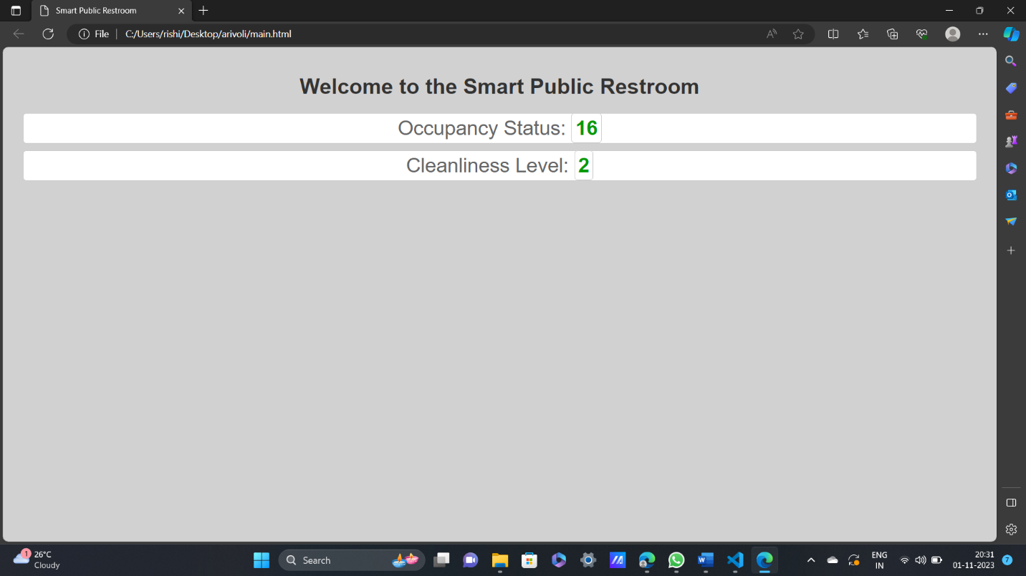

**CONCLUSION:**

Here I created an web page to display occupancy and cleanliness of a restroom. a website for smart public restrooms using IoT technology can enhance user experience, hygiene, and resource management while providing valuable data for decision-making and promoting sustainability. This innovation aligns with the growing demand for technology-driven solutions to improve public facilities and ensure a cleaner and more efficient public restroom experience.